## horizontal line

Any Healthcare Project

**─**

By Group 5:

Aniket Yadav (191012)

Harshit Tiwari(191040)

Parth Singla (192061)

Sudhanshu Yadav (191091)

Tarun Yadav (192094)

# WBS (Work Breakdown Structure)

Work Breakdown Structure or WBS is a tree type structure with end objective on top and successively subdividing into manageable components.

For any health project deciding who will be the target, Forming different management teams, Construction and equipment, Hiring of doctors, Getting government approval and finally attracting the patients.

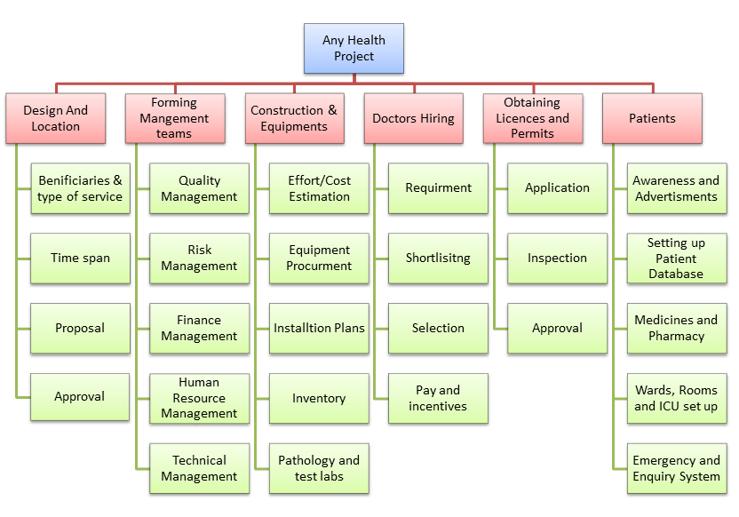

# Activity definition:

Activity definition is tabulation of all activities of project schedule, it contains

○ Activity Name ○ Activity Code ○ Activity Description

|  |  |  |
| --- | --- | --- |
| **Activity Code** | **Activity Name** | **Detailed Activity Description** |
| **A** | **Approval for Design & Location** | Identifying the target location for the health project and making the design on the basis of time span and service provided. |
| **B** | **Setting up Quality Management** | Forming a team that watches over the quality of the project work that is going on. |
| **C** | **Setup Finance Management** | Forming a team which will manage the finances for the successful completion of the project. |
| **D** | **Set up H.R Management** | Forming a team to manage hiring of the staff and deciding salary and incentives. |
| **E** | **Equipment Procurement** | Purchasing the necessary equipment for the smooth functioning of the project. |
| **F** | **Cost analysis** | Analyzing the monetary expenditure of a project, and managing the cost for the future. |
| **G** | **Requirement of Staff** | Judging the number of Doctors and staff are required. |
| **H** | **Hiring staff** | Shortlisting and selecting the capable staff for work. |
| **I** | **Installation Plans** | Installing of the equipment on the basis of requirement. |
| **J** | **Approval & Licenses** | Applying for the Approval and licenses from the government. |
| **K** | **Advertising & Database Setup** | Spreading awareness amongst the people and creating the database for patient details. |
| **L** | **Setting up Pharmacy, Wards, ICU & Specialty Rooms** | Setting up the pharmacy, Rooms, Wards, ICUs for the admission of patients. |

# Activity sequencing

|  |  |  |
| --- | --- | --- |
| **Activity Name** | **Activity Code** | **Immediate Predecessors** |
| **Approval for Design & Location** | **A** | **-** |
| **Setting up Quality Management** | **B** | **A** |
| **Setup Finance Management** | **C** | **A** |
| **Set up H.R Management** | **D** | **A** |
| **Equipment Procurement** | **E** | **B,C** |
| **Cost analysis** | **F** | **C** |
| **Requirement of Staff** | **G** | **D** |
| **Hiring staff** | **H** | **G** |
| **Installation Plans** | **I** | **E,F** |
| **Approval & Licenses** | **J** | **H,I** |
| **Advertising & Database Setup** | **K** | **J** |
| **Setting up Pharmacy, Wards, ICU & Specialty Rooms** | **L** | **K** |

**The equipment procurement is partially affected by financial management.

# Estimate the time duration taken by each identified activity as per your perspective with proper justification

***Activity A***

|  |  |  |
| --- | --- | --- |
| to = 3 | tm = 4 | tp = 5 |
| Poor design, suboptimal maintenance of the built environment, wrong location can increase the risk of transmission of pathogens and can lead to outbreaks.  Novel and best-practice technologies, materials, design strategies, and pleasant location decrease the risk of transmission of pathogens. | | |

***Activity B***

|  |  |  |
| --- | --- | --- |
| to = 2 | tm = 3 | tp = 4 |
| Expertise in a specific area that can help your corporation.  Leadership and management experience, especially in related businesses  Commitment to the business.  Time and energy to devote to board duties.  Integrity and lack of a conflict of interest. | | |

***Activity C***

|  |  |  |
| --- | --- | --- |
| to = 2 | tm = 3 | tp = 4 |
| Healthcare organization can provide efficient healthcare to all their patients when they have strong and organized financial management plans, | | |

***Activity D***

|  |  |  |
| --- | --- | --- |
| to = 2 | tm = 3 | tp = 4 |
| The role of HR managers in the healthcare industry is confined to managing safety and legal issues, ensuring efficient performance, and developing problem-solving and decision-making skills. | | |

***Activity E***

|  |  |  |
| --- | --- | --- |
| to = 4 | tm = 5 | tp = 6 |
| The ultimate objective for procurement is to take a strategic role: contributing to patient-centric, sustainable healthcare | | |

***Activity F***

|  |  |  |
| --- | --- | --- |
| to = 2 | tm = 3 | tp = 4 |
| It indicates which interventions provide the highest "value for money" and helps them choose the interventions and programs which maximize health for the available resources. | | |

***Activity G***

|  |  |  |
| --- | --- | --- |
| to = 2 | tm = 3 | tp = 4 |
| When staffing levels aren't met, patient mortality increases. ... If units don't adequately staff enough professionals to provide the care that patients need based on their acuity level, reimbursement may significantly be affected. | | |

***Activity H***

|  |  |  |
| --- | --- | --- |
| to = 4 | tm = 5 | tp = 6 |
| Healthcare staffing is critical to patient satisfaction because the healthcare workforce is primarily responsible for the patient's care experience. | | |

***Activity I***

|  |  |  |
| --- | --- | --- |
| to = 3 | tm = 4 | tp = 5 |
| Medical equipment planning is a specialized process, which requires a clear understanding of the clinical needs and knowledge of budgeting. | | |

***Activity J***

|  |  |  |
| --- | --- | --- |
| to = 5 | tm = 6 | tp = 7 |
| It's hard to overstate the importance of accreditation in healthcare. Every healthcare organization establishes some internal standards and rules for operations. Going through the accreditation process helps streamline operations, improve the quality of care, and build trust with patients and the community. | | |

***Activity K***

|  |  |  |
| --- | --- | --- |
| to = 3 | tm = 4 | tp = 5 |
| Digital marketing has helped the healthcare industry evolve. By using search engines as a tool, creating targeted outreach with great multi-media content, engaging patients on social media, and taking advantage of campaign data analytics, patient engagement and loyalty is rapidly improved | | |

***Activity L***

|  |  |  |
| --- | --- | --- |
| to = 3 | tm = 4 | tp = 5 |
| Infrastructure must integrate the hospital as the center for acute and inpatient care into the broader health care system. It should also facilitate the seven domains of quality 2 – patient experience, effectiveness, efficiency, timeliness, safety, equity, and sustainability. | | |

|  |  |  |  |  |  |
| --- | --- | --- | --- | --- | --- |
| **ActivityNumber** | **Immediate Predecessors** | **To (Optimistic)** | **Tm (Most Likely)** | **Tp (Pessimistic)** | **Estimated Time Duration**  Te = $\frac{To + 4 .Tm+ Tp}{6}$ |
| **A** | **-** | 3 | 4 | **5** | **4** |
| **B** | **A** | **2** | 3 | **4** | **3** |
| **C** | **A** | **2** | 3 | **4** | **3** |
| **D** | **A** | **2** | 3 | **4** | **3** |
| **E** | **B,C** | **4** | 5 | **6** | **5** |
| **F** | **C** | **2** | 3 | **4** | **3** |
| **G** | **D** | **2** | 3 | **4** | **3** |
| **H** | **G** | **4** | 5 | **6** | **5** |
| **I** | **E,F** | **3** | 4 | **5** | **4** |
| **J** | **H,I** | **5** | 6 | **7** | **6** |
| **K** | **J** | **3** | 4 | **5** | **4** |
| **L** | **K** | **3** | 4 | **5** | **4** |

|  |  |  |
| --- | --- | --- |
| **Activity Name** | **Activity**  **Number** | **Duration** |
| **Approval for Design & Location** | **A** | **4** |
| **Setting up Quality Management** | **B** | **3** |
| **Setup Finance Management** | **C** | **3** |
| **Set up H.R Management** | **D** | **3** |
| **Equipment Procurement** | **E** | **5** |
| **Cost analysis** | **F** | **3** |
| **Requirement of Staff** | **G** | **3** |
| **Hiring staff** | **H** | **5** |
| **Installation Plans** | **I** | **4** |
| **Approval & Licenses** | **J** | **6** |
| **Advertising & Database Setup** | **K** | **4** |
| **Setting up Pharmacy, Wards, ICU & Specialty Rooms** | **L** | **4** |

**Draw a network diagram by AOA technique**

Logical representation of activity is shown in network diagram it helps in:

* Calculate the project duration
* Find the critical activity.

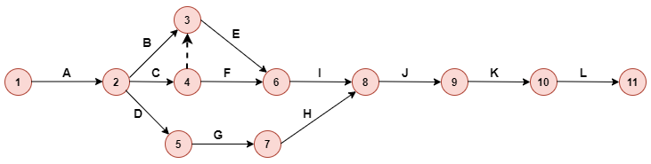

**Analyze the critical path and the total project duration**

**Forward Pass Method**

|  |
| --- |
| *E*1 = **0** |
| *E*2 = *E*1+*t*1,2 [*t*1,2=*A*=4] = 0+4 = **4** |
| *E*3 = *Max*{*Ei*+*ti*,3}[*i*=2,4] = *Max*{*E*2+*t*2,3;*E*4+*t*4,3} = *Max*{4+3;7+0} = *Max*{7;7} = **7** |
| *E*4 = *E*2+*t*2,4 [*t*2,4=*C*=3] = 4+3 = **7** |
| *E*5 = *E*2+*t*2,5 [*t*2,5=*D*=3] = 4+3 = **7** |
| *E*6 = *Max*{*Ei*+*ti*,6}[*i*=3,4] = *Max*{*E*3+*t*3,6;*E*4+*t*4,6} = *Max*{7+5;7+3} = *Max*{12;10} = **12** |
| *E*7 = *E*5+*t*5,7 [*t*5,7=*G*=3] = 7+3 = **10** |
| *E*8 = *Max*{*Ei*+*ti*,8}[*i*=6,7] = *Max*{*E*6+*t*6,8;*E*7+*t*7,8} = *Max*{12+4;10+5} = *Max*{16;15} = **16** |
| *E*9 = *E*8+*t*8,9 [*t*8,9=*J*=6] = 16+6 = **22** |
| *E*10 = *E*9+*t*9,10 [*t*9,10=*K*=4] = 22+4 = **26** |
| *E*11 = *E*10+*t*10,11 [*t*10,11=*L*=4] = 26+4 = **30** |

**Backward Pass Method**

|  |
| --- |
| *L*11 = *E*11 = **30** |
| *L*10 = *L*11-*t*10,11 [*t*10,11=*L*=4] = 30-4 = **26** |
| *L*9 = *L*10-*t*9,10 [*t*9,10=*K*=4] = 26-4 = **22** |
| *L*8 = *L*9-*t*8,9 [*t*8,9=*J*=6] = 22-6 = **16** |
| *L*7 = *L*8-*t*7,8 [*t*7,8=*H*=5] = 16-5 = **11** |
| *L*6 = *L*8-*t*6,8 [*t*6,8=*I*=4] = 16-4 = **12** |
| *L*5 = *L*7-*t*5,7 [*t*5,7=*G*=3] = 11-3 = **8** |
| *L*4 = Min{*Lj*-*t*4,*j*}[*j*=6,3] = Min{*L*6-*t*4,6;*L*3-*t*4,3} = Min{12-3;7-0} = Min{9;7} = **7** |
| *L*3 = *L*6-*t*3,6 [*t*3,6=*E*=5] = 12-5 = **7** |
| *L*2 = Min{*Lj*-*t*2,*j*}[*j*=5,4,3] = Min{*L*5-*t*2,5;*L*4-*t*2,4;*L*3-*t*2,3} = Min{8-3;7-3;7-3} = Min{5;4;4} = **4** |
| *L*1 = *L*2-*t*1,2 [*t*1,2=*A*=4] = 4-4 = **0** |

**(b) The critical paths of the project are :**

(1) 1-2-3-6-8-9-10-11 and critical activities : *A*,*B*,*E*,*I*,*J*,*K*,*L*

(2) 1-2-4-3-6-8-9-10-11 and critical activities : *A*,*C*,*D*,*E*,*I*,*J*,*K*,*L*

**The total project time is 30**



**Float**

|  |  |  |  |  |  |  |
| --- | --- | --- | --- | --- | --- | --- |
| **Activity**  **(*i*,*j*)**  **(1)** | **Duration**  **(*Dij*)**  **(2)** | **Earliest timeStart**  **(*Ei*)**  **(3)** | **Latest Time Start**  **(*Ej*)**  **(4)** | **Earliest Time Finish**  **(*Li*)**  **(5)** | **Latest time Finish**  **(*Lj*)**  **(6)** | **Total Float**  **(*Lj*-*Dij*)-*Ei***  **(7)=(5)-(3)** |
| 1-2 | 4 | 0 | 4 | 0 | 4 | 0 |
| 2-3 | 3 | 4 | 7 | 4 | 7 | 0 |
| 2-4 | 3 | 4 | 7 | 4 | 7 | 0 |
| 2-5 | 3 | 4 | 7 | 5 | 8 | 1 |
| 3-6 | 5 | 7 | 12 | 7 | 12 | 0 |
| 4-6 | 3 | 7 | 10 | 9 | 12 | 2 |
| 5-7 | 3 | 7 | 10 | 8 | 11 | 1 |
| 7-8 | 5 | 10 | 15 | 11 | 16 | 1 |
| 6-8 | 4 | 12 | 16 | 12 | 16 | 0 |
| 8-9 | 6 | 16 | 22 | 16 | 22 | 0 |
| 9-10 | 4 | 22 | 26 | 22 | 26 | 0 |
| 10-11 | 4 | 26 | 30 | 26 | 30 | 0 |